DAY – 5 TASK

1.HOME PAGE HEADER



2.EXPERIENCE FRAGMENT OF HEADER

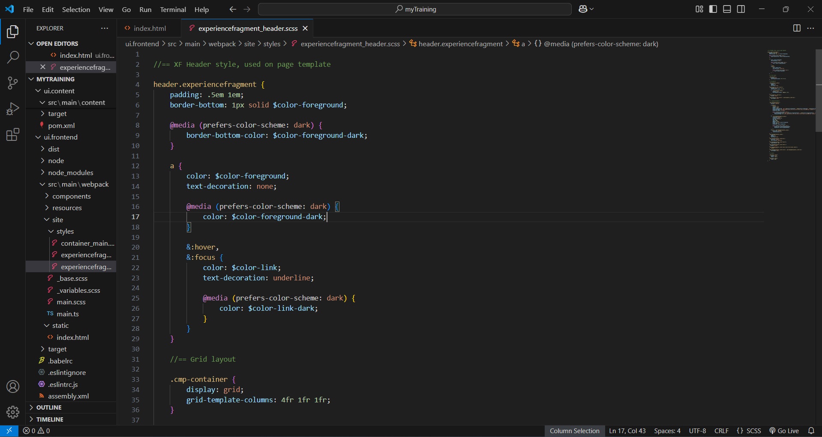

3.EXPERIENCE FRAGMENT OF FOOTER

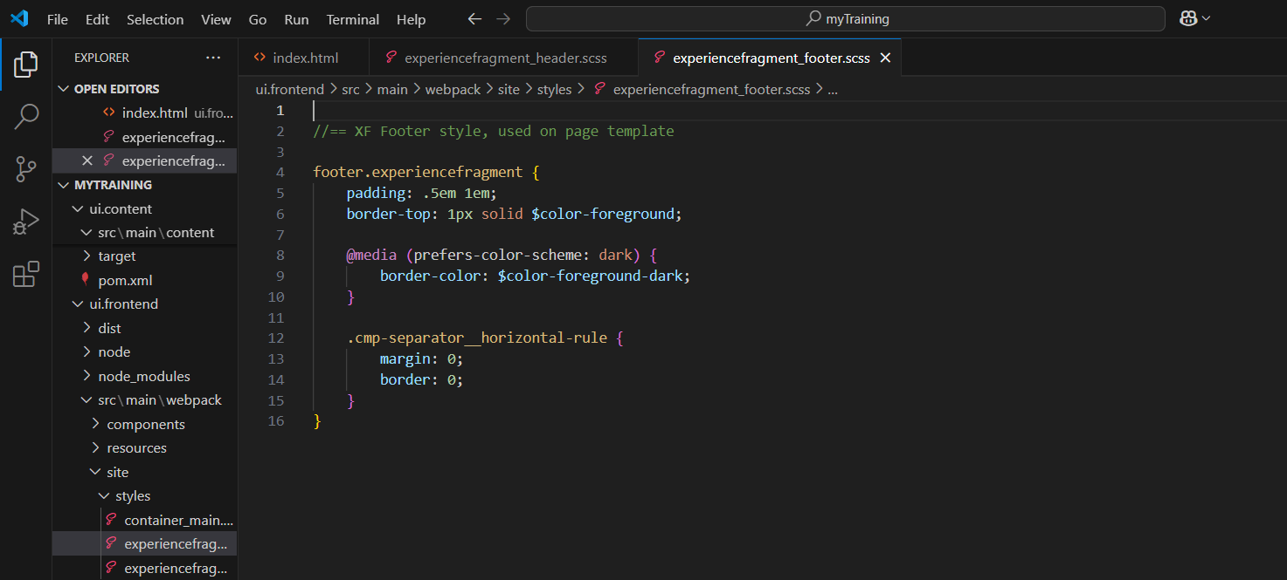

4.CUSTOM PAGE PROPERTY

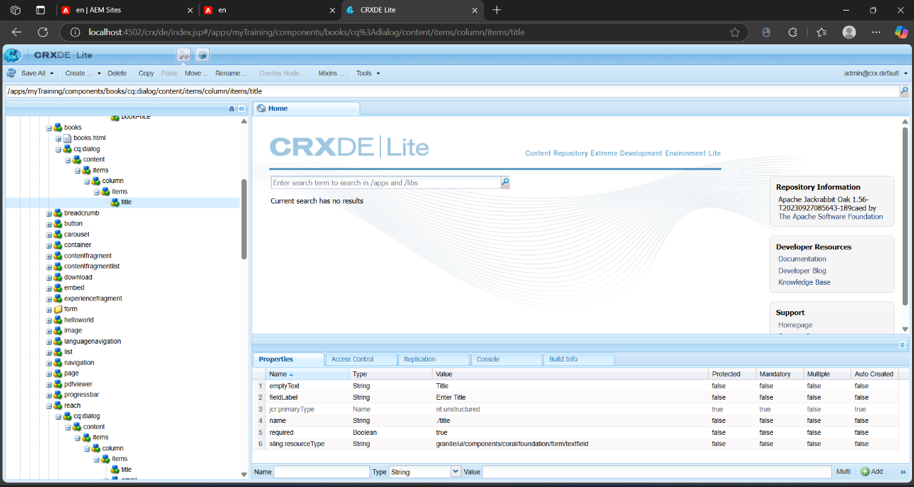

5.UPDATE TO BOOK DETAILS COMPONENT

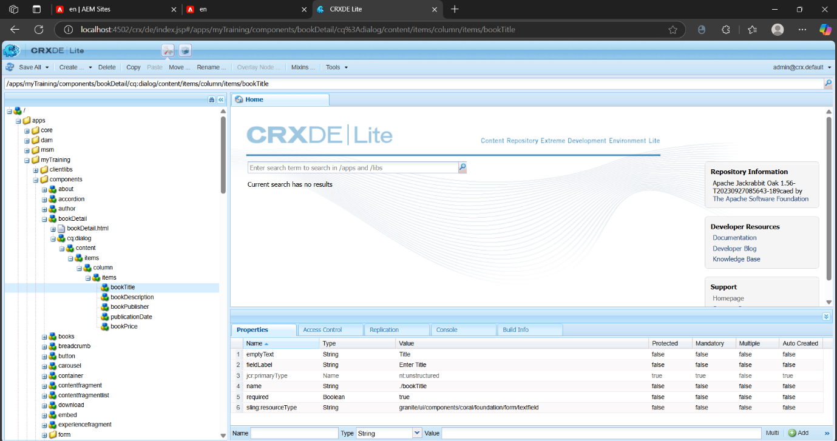

6.AUTHOR DETAILS COMPONENT

